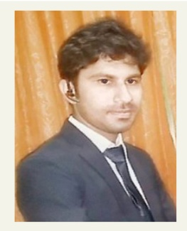
Muhammad Abdullah Zafar

25 CB Adil Town Bahawalpur

Pakistan, 63100

Contact: +923347083757
Passport: BX5520151

Email: azafar.cs@gmail.com

CAREER OBJECTIVE

To pursue a rewarding career in the organization, offering my dedicated service as a member of efficient team in return for excellent training, invaluable experience and opportunities for professional growth.

EXPERIENCE

Dec-2016 – To-date SolutionsPlayer Pvt. Ltd (Islamabad) as a PHP Developer

Apr-2016 – Dec-2016 Free Lancing.

Jan-2016 – Apr-2016 Nestosh (Lahore) as a Software Engineer.

Oct-2015 – Jan-2016 SolutionsPlayer Pvt. Ltd (Islamabad) as a PHP Developer.

6 months Apple Academy Bahawalpur

PROJECTS

Benazir Literary Society: (www.benazirliterarysociety.com)
Complete Literary site that includes CMS and user-side by using two different Templates

Falcon Express (www.falconexpress.com.pk)
Complete Travel site that includes CMS and user-side by using two different Templates.

Assurance
Complete Tax company site that includes CMS and user-side by using two different Templates.

Automobile Site
Complete Autos site that includes CMS and user-side by using two different Templates.

Ecommerce Site
Complete shopping website that includes CMS and user-side by using two different Templates.

Gym Management System
- This is a complete Gym site. Site include CMS and front-end by using 2 different Templates.

TECHNICAL SKILLS

Skills: php5, html5, css3, javascript, C++, bootstrap, wordpress (woocomerce)

Databases: Mysql

Technologies: Adobe Dreamweaver, Xampp, Dev C++, Adobe Photoshop

EDUCATIONAL QUALIFICATION

2015 BS-CS. The Islamia University of Bahawalpur CGPA 3.22.
2011 F.Sc (Pre-engineering) Punjab College Bahawalpur
REFERENCES

Will be provided on deman

